Math 1 Name_______________________________

**5-1 Rotations Practice** Date________

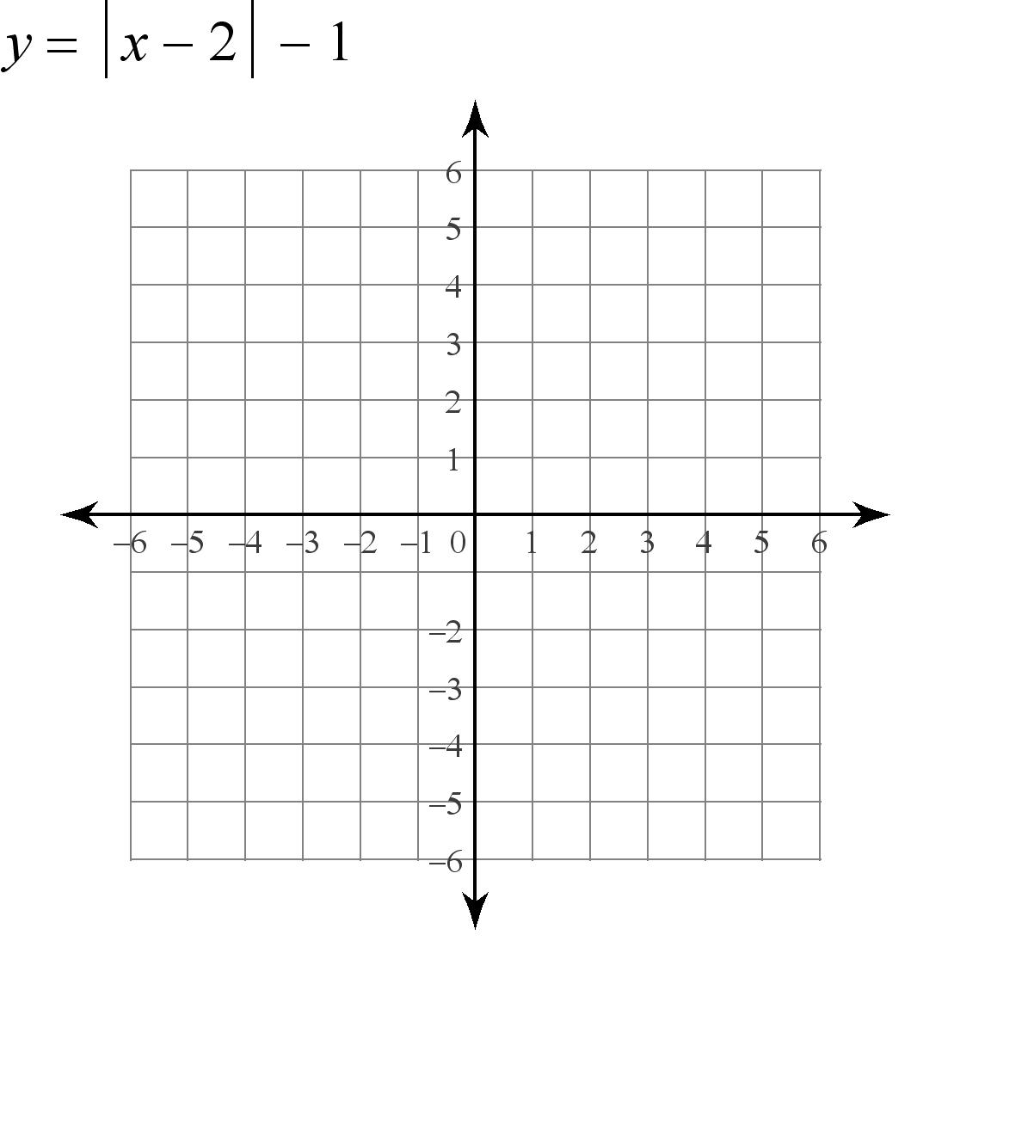1) Rotate BAT where B(-5, 3), A(-1, 4), and T(-2, 2)  counterclockwise about the origin.

B (-5, 3) B’(____,____)

A (-1, 4) A’(____,____)

T (-2, 2) T’(____,____)

Describe how you did the rotation:

Give the rule for a counterclockwise rotation:



2) Rotate BAT where B(-5, 3), A(-1, 4), and T(-2, 2) clockwise about the origin.



B (-5, 3) B’(____,____)

A (-1, 4) A’(____,____)

T (-2, 2) T’(____,____)

Describe how you did the rotation:

Describe the rule for a clockwise rotation:



What do you notice about a 180o rotation counterclockwise vs. clockwise?

What is the rule for any 180o rotation?



3) Rotate GHL, where G(2, 1), H(0, 3), and L(5, 4), counterclockwise about the origin.



G(2, 1) G’(___,___)

H(0, 3) H’(___,___)

L(5, 4) L’(___,___)

Describe how you did the rotation:

Give the rule for a counterclockwise rotation:



4) Rotate WCH, where W(-3, -1), C(-4, -3), and H(-1, -3), clockwise about the origin.



W(-3, -1) W’(___,___)

C(-4, -3) C’(___,___)

H(-1, -3) H’(___,___)

Describe how you did the rotation:

Describe the rule for a clockwise rotation:



5) Rotate WCH, where W(-3, -1), C(-4, -3), and H(-1, -3), counterclockwise about the origin.

W(-3, -1) W’(___,___)

C(-4, -3) C’(___,___)

H(-1, -3) H’(___,___)

Describe how you did the rotation:

Describe the rule for a clockwise rotation:



Compare your rules for 90o clockwise and 270o counterclockwise rotations. Why is it like this?

**Rotate each triangle as indicated by the problems below.**

6) ΔRST: R(2, -1), S(4, 0), and T(1, 3) 90° 7) ΔFUN: F(-4, -1), U(-1, 3), and

 counterclockwise about the origin. N(-1, 1) 180° counterclockwise about the origin.

R’ (___,___) S’(___,___) T’(___,___) F’ (___,___) U’(___,___) N’(___,___)

8) ΔRST: R(2, -1), S(4, 0), and T(1, 3) 270° 9) ΔCDY: C(-4, 2), D(-1, 2), and Y(-1, -1)

 clockwise about the origin. 180° clockwise about the origin.

R’ (___,___) S’(___,___) T’(___,___) C’ (___,___) D’(___,___) Y’(___,___)

10) ΔMCG: M(-3, 1), C(-1, 3), and G(-1, -1) 90° 11) ΔBWM: B(-3, 1), W(-1, 3), and M(-1, -1) 270°

 clockwise about the origin. counterclockwise about the origin.

M’ (___,___) C’(___,___) G’(___,___) B’ (___,___) W’(___,___) M’(___,___)